John Deardurff

Microsoft Corporation

SQL SErver Performance Tuning Workshop Setup Instructions

Contents

Redeeming the Training Key 1

You only need to redeem the training key one time. 1

Navigating Virtual Lab Environment 3

Signing into the Virtual Machine 3

Redeeming the Training Key

You only need to redeem the training key one time.

1. The training key will be provided by the instructor before class.
2. Navigate to <https://aka.ms/LearningCampus>
3. Sign in with your personal Microsoft account not your Corporate AAD account
   * If you do not have a personal Microsoft account, then create one here: [http://live.com](https://outlook.live.com/owa/)

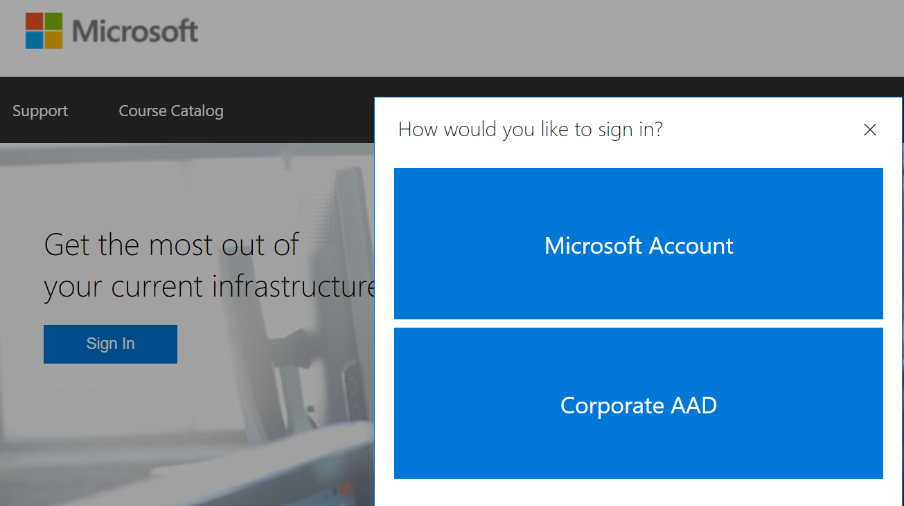

1. Select WorkshopPlus from the navigation bar and click on My TrainingGraphical user interface, text

   Description automatically generated
2. Select Redeem Training Key. Text

   Description automatically generated with medium confidence
3. Type in your **Event Training Key:** Graphical user interface, application

   Description automatically generated with medium confidence
4. To access the virtual labs, Select WorkshopPlus and click on My Training. Graphical user interface, text, application

   Description automatically generated
5. Click on the Name of your class.

1. Click Launch to start Virtual Machine.

Navigating Virtual Lab Environment

Signing into the Virtual Machine

1. In the instructions area, click on Resources. Graphical user interface, application

   Description automatically generated

2

1

1. Then Click on the Ctrl + Alt + Delete button.
2. Click in the Password box and type in Pa$$w0rd1 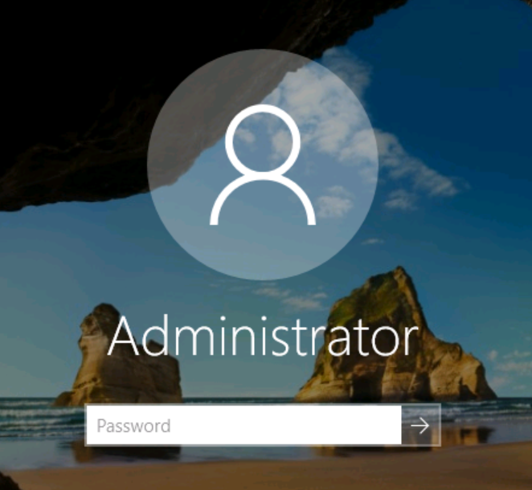
3. You could also click the Green T from the resource box. Graphical user interface, website

   Description automatically generated
4. To end the lab, click on the three-line menu option in the top right.
   * Save will close your lab and save any of your changes.
   * End will close the lab but not save any of your changes.
   * Split Window will allow you to move your instructions to a different monitor. Graphical user interface, text, application

     Description automatically generated
5. Graphical user interface

   Description automatically generatedYou can also use the lightning bolt in the top right corner to paste code from outside your virtual machine into your lab environment.